Some histological studies on the proventriculus of the quail during pre and post hatching periods
By
Hossam Fouad Attia
Dept. of Histology &Cytology. Faculty of Vet. Med. Benha University
Summary
This study was carried out on the histological structure of the proventriculus during pre and post hatching periods. The primordial of the proventriculus was appeared at three day post incubation and was appeared as closed tube with star shape lumen. The primordial epithelium was stratified columnar epithelium, and then the number of the epithelium layers was decreased to become columnar epithelium at 8 days post incubation. Compound tubuleoalveolar gland extends from the star shape tube at 4days post incubation which was lined with mass of stratified epithelium and represent the glands. The glands were developed, branched and occupy the propria submucosa of the gland by age advanced and were lined by mucous cells and cuboidal cells. The mesenchymal cells that surround the primordial tube were differentiated to be the next propria and submucosa of the proventriculus at 11 days post incubation periods. The myoblast cells in the surrounding mesenchymal cells were differentiated to inner circular and outer longitudinal smooth muscle fibers of the tunica musclosa. The tunica serosa was appeared and clearly arranged at 9 days post incubation. The histological structure of the proventriculus post hatching had the same feature of the late pre hatching period except there was increase in the size of the gland and increase in the surface area of the glands.

Introduction
The proventriculus, a glandular organ, corresponds to the stomach of other animals as it produces a gastric juice containing acid and enzymes. It differs in that little mixing or holding of food occurs in it. The up to date mission of the food scientists was based on, saving high quality, palatable, cheap and environmental hygienic food of animal origin. Their target was the quail's meat (Bader, 2005). The quail proventriculus with its enzymatic activities played a major role in the turnover of the ingested food to give good quality meat. The proventriculus was studied by many authors (El-Banhawy, 1993) in chicken (El-Zoghby, 2000) in turkey, (Prasad and Krishna, 1990) in duck and (Hassouna, 2001) in goose. The birds, to maintain their high metabolic level, utilize the most of their time for search of the food. Our interest was directed to the histological description of the proventriculus in the quail during the pre and post hatching periods.

Materials and methods
The fertilized eggs of the quail were collected from the quail farms and were opened for the collection of the whole embryo chicks during the pre hatching periods at 1, 3, 4, 7, 11, 15, 18 days post fertilization. While the proventriculus was collected from the post hatched chicks at 3,8,16,29,51 days post hatching. The specimens were dissected and immersed in Susa fluid, then dehydrated in alcohols , cleaned in xylene and embedded in soft paraffin and cuted at 5 um and were stained with hematoxyline & eosin (Harris, 1898) for general character , Crossmon,s trichrome ( Crossmon's, 1937) for identification of collagen fibers ,silver impregnation technique ( Gomori, 1937) for identification of reticular fibers and combination of PAS and alcian blue for identification of neutral and acid mucopolysacharides ( Mowry ,1956) .
Results
1-Prehatching periods
The primordial of the quail proventriculus was appeared at 3 days post fertilization as closed tube with star shape lumen. It was lined with stratified columnar epithelium which was rest on definite basement membrane (Fig.1).
The primordial epithelium was surrounded with different shapes of mesenchymal cells. Both of the primordial epithelium and the mesenchymal cells were PAS positive reaction, while the cells apex was appeared strong PAS positive reaction (Fig.2).
Myoblast cells were arranged at the periphery of the mesenchymal cells with eosinophilic cytoplasm and positive PAS reaction. It was represented the future tunica musclosa.
Long tubular shape gland was extending from the star shape lumen as out pouching into the mesenchymal cells at the age of 4 days post incubation. These out pouching were end with dilatation which was formed from mass of stratified cells with centrally located nuclei and eosinophilic cytoplasm (Fig.3).
Both of the size and the number of the glands were increased with the age advanced at 8 days post incubation and were appeared as compound tubuleoalveolar gland. These glands still lined by stratified epithelium. The glands were arranged in lobules separated from each other by thick CT septa (Fig.4). The surface epitheliums of the proventriculus were decreased in number and crowdedly cover the mucous membrane of the proventriculus. The epithelium was simple columnar epithelium with basely situated basophilic nuclei and eosinophilic cytoplasm, with no evidence of goblet cells in between them.. The proventricular glands were lined with stratified columnar epithelium with wide lumen, but some glands were still undifferentiated and appeared as mass of stratified cells (Fig.4). The mesenchymal cells were differentiated to became loose CT which was represented the lamina propria that was enclosed the proventricular gland. The tunica musclosa was arranged into thin inner circular and thick outer longitudinal smooth muscle fibers (Fig.5). The tunica serosa was appeared and arranged clearly as loose CT enclosed by thin sheet of mesothelial cells at 9 days post incubation. Both of the glandular epithelium and the tunica muscularis were PAS positive while the CT fibers of the propria and submucosa and that of the smooth muscles were alcianophilic fibers (Fig.6).
The numbers of the lobules of the gland were increased and completely occupied the propria submucosa. The CT septa were decreased in thickness at 13 days post incubation (Fig.7).
The proventricular glands were arranged in the form of branched and anastomosing units while the others were arranged in the form of short and long cords around wide central lumen in each lobule at 15 days post incubation. (Fig.8). The CT septa were represented by collagen fibers which also extend between the muscles of the tunica musclosa (Fig.8), and reticular fibers which were enclosed each unit of the gland and also were extend in the CT septa (Fig.9) at 18 days post incubation.
2-Posthatching periods
The histological structure of the proventriculus at 3-8 days post hatching had the same histological structure of the proventriculus at late post incubation period, but the size and number of the gland lobules was increased. The muscular wall was increased while the septa were decreased in comparative to the late post incubation period (Fig.10).
The histological structure of the quail proventriculus at 16-51 days post hatching was characterized by cuboidal epithelial cells with dark eosinophilic cytoplasm and centrally located basophilic nuclei ( Fig.11). the glands increase in size and arranged as anastomosing units lined by cuboidal epithelium (Fig.12 ).
Discussion
None of the previously mentioned authors give an attention to the histological sequence of the development of the proventriculus as regularly steps. Although there were some trials in the duck (Martinez, Lopz and Sesma, 1993) and in the turkey (El-Zoghby, 2000), but not start from the beginning as that of the present work in the quail.
The present work was showed that the primordial of the quail's stomach as star shape tube lined by stratified columnar epithelium at 3 days post incubation. The development of the embryonic proventriculus was done at 5th days post incubation in duck (Martinez, et al, 1993). While it became prominent at 7th days post fertilization in gallus domesticus and begins to branch at 10th days, it increase more and more up to 13th days.
The epithelium lining of the proventriculus was stratified columnar epithelium, and then it decreased in number at 9 days post fertilization, and became columnar epithelium. This finding was supported by the finding of (Lim&low1977), which recorded that the surface epithelium was stratified columnar epithelium and then by the steps of the development became simple columnar epithelium. While the epithelium of the stomach was stratified columnar up to 11-16days post incubation and then differentiated to simple columnar epithelium between 17-20 days post incubation (Vanalten and Fennell, 1957). The epithelial lining was mucous secreting cells ( Hibbard,1942).
The present data revealed that the proventricular glands were multilobular .Each lobule consisted of closely packed tubular alveoli that drained into a central cavity via tertiary duct. The proventricular gland alveoli were formed from one cell type (Oxynticopeptic cell), the proventriculus cells give hydrochloric acid & proteolytic enzymes (Randall&Reece,1996). The proventricular tubules were composed of cuboidal cells (Calhoun, 1954 and Bragulla, et al.,2001 ).
In the present work, no L.m.m was recorded in the mucosa of the gland although most of the authors were mentioned it .The L.m.m was located above and beneath the gland (Bradley, 1950). However (Farner,1964) and (Czarnecki,1977) reported that the proventriculus gland penetrate the L.m.m during their development and separate it into inner and outer part
The lining epithelium of the proventriculus is columnar epithelium while it is of prismatic type in other species ( HODGES, 1974; FIERI; LIMA, 1979 and 1985; KLEM et al., 1982 and 1984; ROCHA; SELANDER, 1963; SINGH, 1973; VIAL et al., 1977 and BEE DE SPERONI & CHIKILIAN, 1983.
In the present study, we noted that there is no change difference between the epithelium lining of the proventriculus in both pre and post hatching periods especially the simple columnar epithelium covered the mucous membrane. This finding was augmented by the finding of (Deubner, 1995).
The present data showed that the quail's proventriculus was compound tubular gland. It consists of numerous lobules separated by CT septa and forms the main bulk inside the mucosa. This finding was supported by the observation of (Prasad and Krishna,1992).
Some authors have found the proventriculus simple tubular glands lined by simple columnar epithelium (FIERI; ROCHA and ESPINOLA & GALLIUSSI, 1990).
The present results revealed positive PAS reaction in the surface epithelium and the cuboidal epithelium of the glands, while faint positive reaction in the muscle fibers of the tunica musclosa . These findings were augmented by the results of (Hinsch, 1967b) in chicken and (El-Zoghby 2000) in turkey. This positive PAS coat that covers the surface epithelium may have protective role in avoiding the effect of HCL on the mucous membrane of the proventriculus (Windle, 1960 and Prasad and krishna1990).
The tunica musclosa of the quail's proventriculus was consisted of thin inner circular and outer longitudinal smooth muscle fibers. On the other hands most of the poultry species contain three layers of smooth muscles. (ESPINOLA & GALLIUSSI and BANKS 1991) and (HODGES, 1974)
The description of the serosa of the proventriculus was constituted by connective tissue, containing many blood vessels and nerves, lined by mesothelium. This finding was augmented in most results of (Roch,1991) and (Rocha, and Lima,1998)
List of figures
Fig.1: Photomicrograph of the quail embryo at 3 days post fertilization showing; the primordial of the proventriculus which appear as star shape lined by stratified columnar epithelium (E) and surrounded by mesenchymal cells (M). Notice the presence oh hepatic primordial (L).
H&E………………………………………………………………..X100
Fig.2: Photomicrograph of the quail embryo proventriculus at 3 days post fertilization showing; the proventriculus epithelium (E), mesenchymal cells (M) and the myoblast (M).
H&E………………………………………………………………..X400
Fig.3: Photomicrograph of the quail embryo proventriculus at 3 days post fertilization showing; the Pas reaction in the epithelium (1), in the mesenchymal cells (2) and in the myoblast cells (3)
PAS& alcian blue combination……… …………………………..X400
Fig.4: Photomicrograph of the quail embryo proventriculus at 4 days post fertilization showing; the proventricular gland out pouching (G), mass of epithelial cells (S) and the mesenchymal cells (m)
H&E………………………………………………………………..X100
Fig.5: Photomicrograph of the quail proventriculus at 8 days post fertilization showing; the lobules of the proventricular glands (L) and the Ct septa (CT).
H&E………………………………………………………………..X100
Fig.6: Photomicrograph of the quail proventriculus at 8 days post fertilization showing; the columnar epithelium of the stomach mucosa (C), the tunica musclosa (M), the lobules of the glands (L) and the developing glands (G)
H&E………………………………………………………………..X100
Fig.7: Photomicrograph of the quail proventriculus at 8 days post fertilization showing the PAS positive reaction and alcian blue positive reaction in the proventriculus PAS& alcian blue combination………………………………………………………..X100
Fig.8: Photomicrograph of the quail proventriculus at 12 days post fertilization showing; the lobules of the proventricular gland (L), the duct of the gland (D) and the tunica muscularis (M)
Crossman's trichrome……………………………………………..X400
Fig.9: Photomicrograph of the quail proventriculus at 12 days post fertilization showing; the; the reticular fibers between the secretory adenomeres of the gland and the CT fibers of the tunica muscularis ( R).
Gomori stain…………………………………………………..X400
Fig.10: Photomicrograph of the quail proventriculus at 15 days post fertilization showing; the; the thin CT fibers between the secretory adenomeres of the gland (C ) and the thick muscular wall (M).
H&E……………………………………………………………..X400
Fig.11: Photomicrograph of the quail proventriculus at 16 days post fertilization showing; the; arrangement of the secretory adenomeres of the proventricular glands into cords ( C) and thick muscular wall (M).
H&E………….…………………………………………………..X400
Fig.12: Photomicrograph of the quail proventriculus at 16 days post fertilization showing; the; arrangement of the secretory adenomeres of the proventricular glands into anastomosing cords ( A) and thick muscular wall (M).
H&E………….…………………………………………………..X400

REFERENCES
Bader, W.S (2005): Bacterial evaluation of quail meat. M.V. Sc. Thesis. Faculty of veterinary medicine. Benha University.
Bee De Speroni, N. & Chikilian, M.(1983): Estudio morfohistologico e histoquimico comparado de la primeira porcion del tracto digestivo de Zenaida auriculata chrysauchenia y Myiopsitta monacha monacha (aves Columbidae y psittacidae). Hist. Nat. Corrientes, 3:21-32.
Bragulla, Hermann; Hirschberg, Ruth; Heidbrink, Stefanie (2001): Comparative morphology of the gastrointestinal tract
in raptorial birds.. Journal of Morphology, 2001, v. 248 (3), p. 209.
Bradely, O. C.(1951):. The structure of the fowl. 3. ed. Philadelphia, J.B. Lippincot . pp 29-48.
Calhoun, M. L.(1954): Microscopic anatomy of the digestive system of the chicken The IOWA. State College Press.Ames, Iowa,. 108p.
Crossmon, G. (1937): A modification of Mallory's connective tissue stain with a discussion of the principles involved. Anat. Rec. 69: 33 -83.
Czarnecki,C. M (1977): The proventricular gland of the chick. Areappaisal from a developmental point of view. Acta anat.,98: 77-82.
Deubner, K. (1995): Histological, immunocytochemical and ultrastructural research of the mucous membrane of proventriculus and pyloric gland area of chicken (gallus gallus var. dom.), after hatching until the sixth week of life,
before and after stimulation with cold feed extracts,
using an In-vitro test system.Veterinary thesis, Munich.
ElBanhawy, A. M ; Mahmoud E. Mohallal; Tarek R. Rahmy and Tarek I. Moawad (1993): Histological adaptation in the digestive organs of birds with various dietary peculiarities. J. Egypt. Ger. Soc. Zool Vol. (12C) 153-170 1993

El-Zoghby,I.A (2000): Histological and histochemical studies on the digestive tract of the turkeys at different ages.Ph. D. Thesis. Faculty of veterinary medicine. Benha University.
Farner, D. S. (1960): Digestion and digestive system. In: MARSHALL, A. J., Biology and comparative Physiology of birds. New York, Academic Press, pp 411-49.
Gomori,G.(1937): Am.J.Path.13:993. Cited after Drury and Walgton (1967).Carlton histological technique, 4th ed.Oxoford.Univ.Press.Newyork, Tronto.
Harris, H.E (1898): Cited after Drury and Walgton (1967). Carlton histological technique, 4th ed.Oxoford.Univ.Press.Newyork, Tronto.
Hassouna, E.M.A(2001): Some anatomical and morphometric studies on the esophagus and stomach of goose, turkey, sparrow,
kestrel, hoopoe, owl and darter. Assiut Veterinary Medical Journal, 2001, v. 44 (88), p. 21-46.

Hibbard, H (1942): The golgi apparatus during development in the stomach of Gallus Domesticus . J. Morph.70:121-149.
Hinsch, G.W (1967b): Histochemical patterns in the proventriculus of the developing chich. J. Morph.122:231-248.
Hodges, R. D. (1974): The histology of the fowl. London, Academic Press, pp 35-88.
Klem. JR., D.; Bbrancto, C.R.; Catalano, J. F. & Huzmin. F. L.(1982): Gross morphology and general histology of the esophagus, ingluvies and proventriculus of the House Sparrow (Passer domesticus). Proc. Pa. A cad. S ci., 56:141-6..
Klem. JR., Parker, M. A.; Sprague, W. L.; Tarufi, S. A.; Veltri, C. J. & Walker, M. J. (1984): Gross morphology and general histology of the alimentary tract of the american robin (Turdus migratorius). Proc. Pa. Acad. Sci., 58:151-158.
Lim,S.S and Low,F.N (1977): Scanning electron microscopy of the developing alimentary canal in the chick.Am.J.Anat.150:149-173.
Martinez, A. Lopz J and Sesma,P ( 1993): Development of the diffuse endocrine cells in the chicken proventriculus.Cell Tissue Rese.271:107-113.
Mowry, R.W (1956): Observation on the use of sulphuric ether for the sulphation of hydroxyl groups in tissue sections. J. Histochem.Cytochem.., 4:407-412.
Prasad, R.V and Krishna, K ( 1990): Histology and histochemistry of proventriculus of domestic duck. Mysore J. Agric.24:506-511.
Prasad, R.V and Krishna, K( 1992): Histology and histochemistry of the proventricular-gizzard junction and gizzard of domestic duck. Ind.Vet. J. Agric. 4:329-332.
Randall,C.J &Reece,R.L (1996): Color atlas of avian histopathology. New South Wales, Australia.
ROCHA, S.O. (1991): Aspectos morfolَgicos (histolَgicos) do tubo digestivo da coruja-buraqueira Speotyto cunicularia, (Molina, 1782). So Paulo, 1991. 73 pp.
Rocha,S.O and Lima, M.A.(1998): Histological aspects of the stomach of burrowing owl. Speotyto cunicularia, MOLINA, 1782). Rev. chil. anat. v.16 n.2 Temuco 1998
Salem,H.F (1985): Histological and histochemical studies on the stomach and intestine of fayomi fowl with special reference to age and ration variation. Ph.D.Thesis. Fac.Vet.Med.Zagazig University.
Singh, S. P. (1973): Morpho-histological observations on the proventriculus in some birds viz., Ploceus phiiipplnus, Upupa epops; Megalaima haemacephala and Cinnyris asiatica. Zool. Anz., 191:45-50, .
Vanalten,P.J and Fennell,R.A (1957): Histogenesis and histochemistry of the digestyive tract of chicks embryo.Anat.Rec127:677-695.
Vial, J.D.; Garrido, J.; Dabike, M. &Koenig, G. (1977): Muscle proteins and the changes in shape of avian oxynticopeptic cells in relation to secretion. Anat. Rec., 194:293-310.
Windle,W (1960): Text book of histology .III ed. McGraw-Hill.

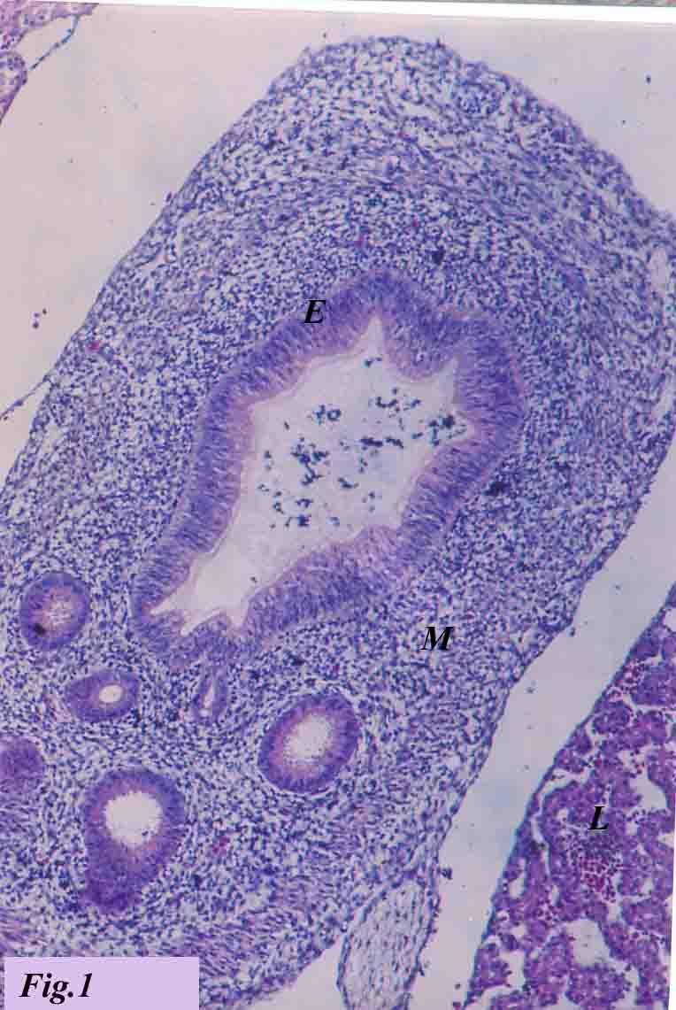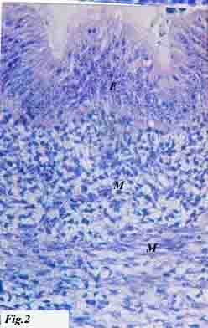
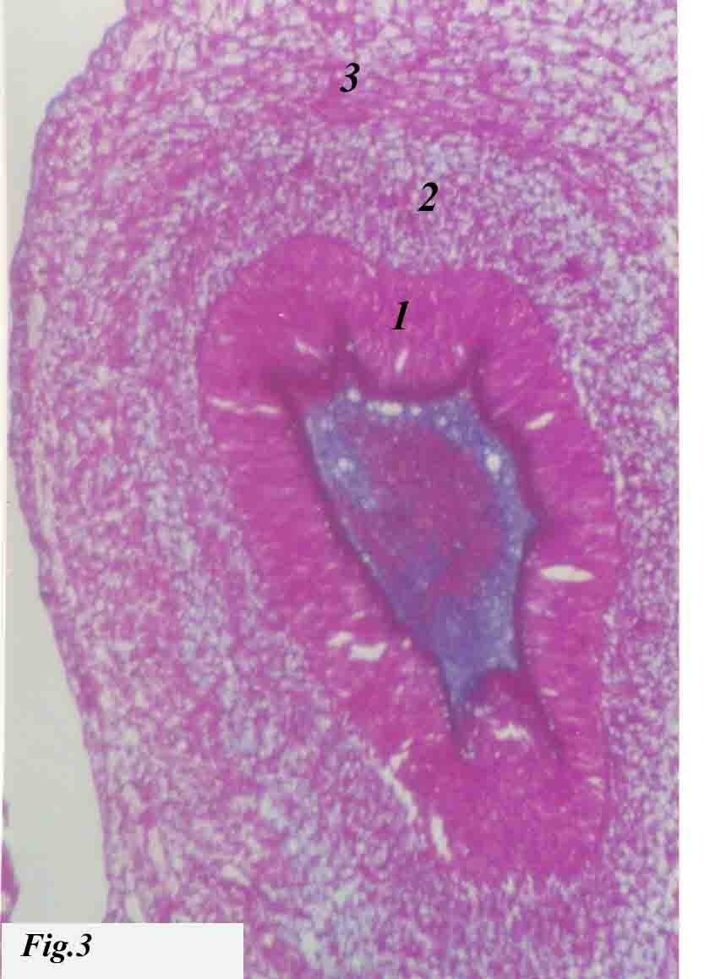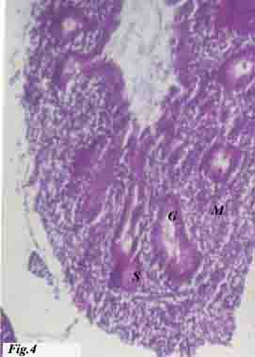

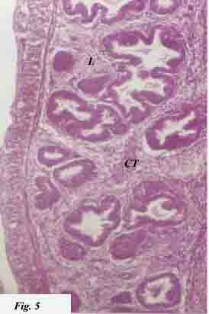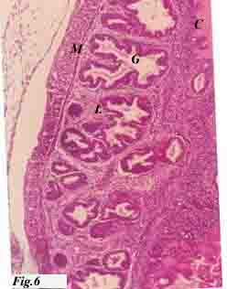

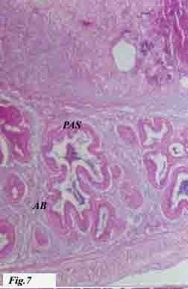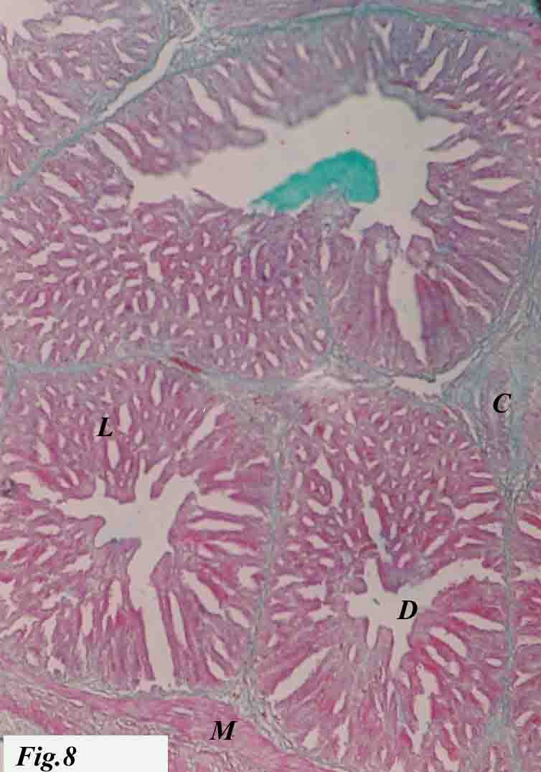

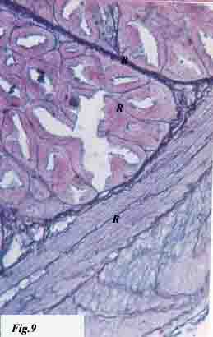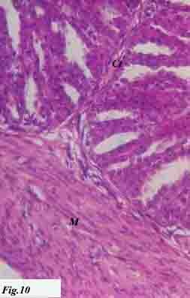
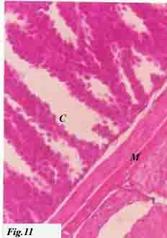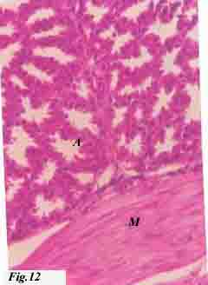

بعض الدراسات الهستولوجيه علي المعده في السمان قبل وبعد الفقص

حسام فؤاد عطية
قسم الانسجه والخلايا- كلية الطب البيطرى
جامعــة بنهــا
- اجريت هذه الدراسه علي عدد 25 معده سمان قبل وبعد الفقص لبيان التركيب الهستولوجي للمعده في السمان
- بدأ ظهور منشأ المعده كانبوبه نجميه الشكل مبطنه بخلايا عديده اسطوانيه الشكل في عمر 3 أيام في مرحله قبل الفقص ثم اصبح النسيج الطلائي يتكون من طبقه واحده اسطوانيه الشكل في عمر 8 أيام
- بدا ظهور الغدد الافرازيه في عمر 4 ايام كانبوبه ممتده من المنشا النجمي الشكل وكانت مبطنه بخلايا عديده والتي سرعان ما تميزت الي خلايا مكعبه الشكل وهذه الغدد تملا البقه المخاطيه وتحت المخاطيه علي شكل فصوص يفصل بينها فواصل غرويه
- بدا تميز الطبقه المخاطيه وتحت المخاطيه في عمر 9 ايام بينما تميزت الطبقه العضليه في عمر 11 يوم بينما الطبقه المصليه تميزت في عمر 9 ايام
- المعده في مرحله بعد الفقص تتكون من نسيج طلائي من خلايا اسطوانيه يغطي المعده بينما توجد الغدد الافرازيه ذات فصوص كثيره العدد مبطنه بخلايا مكعبه وهذه الغدد مرتبه اما في شكل احبال أو خيوط متشابكه و تملا البقعه المخاطيه وتحت المخاطيه علي شكل فصوص يفصل بينها فواصل غرويه
- تتميز المعده بازدياد حجم الجدار العضلي والذي يتكون من عضلات ملساء

